Part 1: -

1.1)

|  |  |  |  |  |
| --- | --- | --- | --- | --- |
| **Network Types** | LAN (Local Area Network) | MAN (Metropolitan Area Network) | WAN (Wide Area Network) | PAN (Personal Area Network) |
| usage | Connects computers in a localized area.  For example,  Network inside the student's computer room.  Network within a data center.  Network inside your home. | Connects computers within the metropolitan area.  For example,  several buildings located in three different areas.  Campus area network. | A network that uses long-distance communication links to connect two or more computers located in different, widely spaced locations.  For example,  A network of bank cash dispensers.  The Internet. | Connecting the computer devices of personal use.  For example,  The connection between the pc and printer. |
| benefits | 1. Resource Sharing. 2. Software Sharing. 3. Convenient Communication. 4. Centralized Data. 5. Improved Security. 6. Internet Sharing. 7. Computer Identification. | 1. **Less Expensive.** 2. **Sending Local Emails.** 3. **High Speed than WAN.** 4. **Sharing of the Internet.** 5. **Converting LAN to MAN is easy.** 6. **High Security.** | 1. Covers large geographical area. 2. centralized data. 3. Get updated files and data. 4. Sharing of software and resources. 5. High bandwidth. | 1. No extra space requires. 2. No need of extra cable and wire. 3. Data can Synchronize between different devices. 4. Connect to many devices at a time. 5. No extra space requires. 6. Affordable Cost. 7. Easy to use. 8. Security. |
| constraints | 1. Implementation Cost. 2. Policy Violations. 3. Security. 4. Maintenance. 5. Area Coverage. 6. Server Crashes. 7. Malware Spreading. | 1. **Difficult to Manage.** 2. **Internet Speed Difference.** 3. Hackers Attack. 4. Technical Staff Requires to Set up. 5. **Need More wires.** | 1. Security problems. 2. Needs firewall and antivirus software. 3. The setup cost is high. 4. Troubleshooting problems. 5. Maintenance Issues. | 1. Less distance range. 2. Interfere with radio signals. 3. Slow data transfer. 4. Health problem. 5. Costly in terms of communication devices. 6. Infrared signals travel in a straight line. |

what network types to be used for the project?

1) LAN (Local Area Network).

2) WAN (Wide Area Network).

3) PAN (Personal Area Network)

1.2)

a) Physical Topology-Star: - 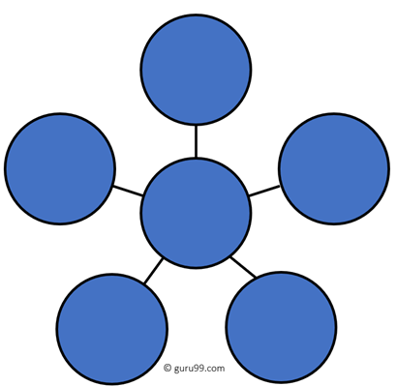

All devices are connected to the hub or switch.

It is used in the local area network and is inexpensive and easy to install.

b) Physical Topology-Bus: -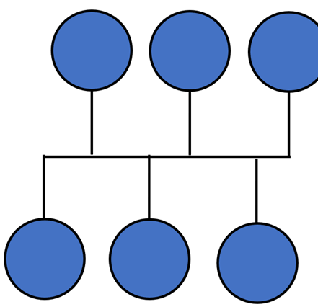

It uses a single cable that connects all the nodes. A single cable called a backbone. Not all devices can send messages but only one device. It has two endpoints.

c) Physical Topology-Ring: - 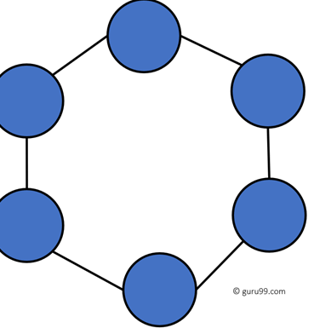

In a ring network, every device has exactly two neighbouring devices for communication purpose. called ring topology because its configuration is similar to a ring.

d) Physical Topology-Tree: - 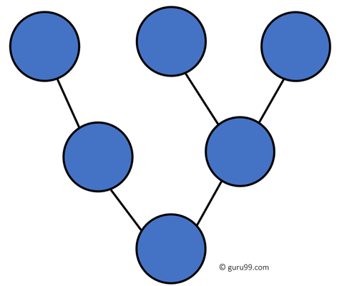

called also as the hierarchical topology. Connects the star and bus topology in one topology.

|  |  |  |  |  |
| --- | --- | --- | --- | --- |
| Network topology | Star | Bus | Ring | Tree |
| characteristics | 1.All cables run to a central connection point.  2. If a cable breaks or fails, the computer will not be able to connect to that cable causing the network to not be used.  3.A star topology is scalable.  4. The PC can be added or removed from the central connection point.  5. Increase the cost of network expansion and maintenance. | 1. Cost of the cable is very less as compared to other topology.  2. Famous for LAN network because they are inexpensive and easy to install.  3. Only one computer can send messages at a time.  4. If the cable connection fails, the whole system will fail.  5. Each computer receives the message but ignores it if not addressed to it. | 1. Data travels around the ring in one direction.  2. Failure of one computer can disturb the whole network.  3. Faster error checking and acknowledgment.  4. It is very difficult to troubleshoot the ring network.  5. Easy to install and reconfigure. | 1. Failure of one node never affects the rest of the network.  2. Node expansion is fast and easy.  3. Detection of error is an easy process.  4. It is easy to manage and maintain.  5. If more nodes are added, then its maintenance is difficult. |

comparison between any two of the network topologies of your choice:

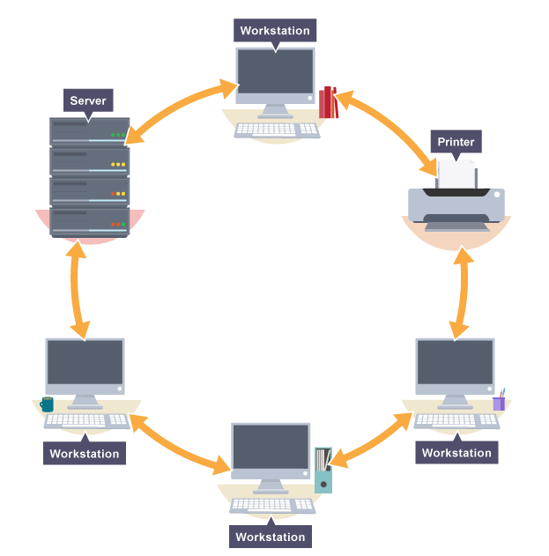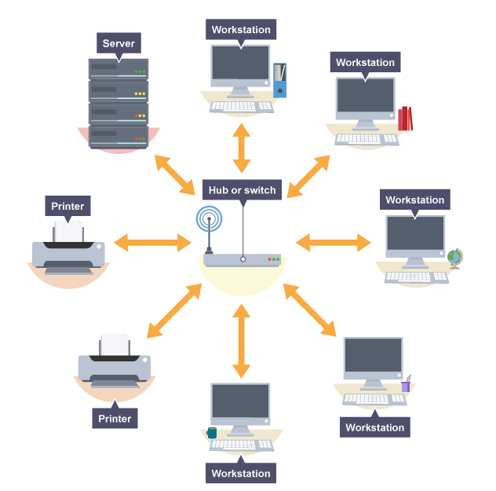

|  |  |  |
| --- | --- | --- |
| Network topology | Ring | Star |
| Usage | The Ring Topology is used in meetings that are in one room. | The star topology uses in one building or in several rooms. |
| advantages | 1.Fast data transfer.  2.It only flows in one direction, so there will be no data inconsistency. | 1.If one of the cables or one of the devices fails, the rest of the cables or the other devices will continue to work.  2.It is high performance as no data conflict can occur. |
| disadvantages | In the event of a failure cable or a malfunction of any device, the entire network will not work. | 1.Network cable is expensive.  2.When adding hardware (hubs or switches), increases the cost.  3.If the hub or switch error, all devices connected to the network will not have a connection. |

1.3) Network protocol: OSI model:

1. DHCP: Dynamic Host Configuration Protocol.

Network Layer

2. DNS: Domain Name System protocol.

3. FTP: File Transfer Protocol.

4. HTTP: Hypertext Transfer Protocol.

Application Layer

5. HTTPS: Hypertext Transfer Protocol Secure.

6. POP3: Post Office Protocol (version 3).

7. SMTP: Simple Mail Transfer Protocol.

8. TCP: Transmission Control Protocol.

Transport Layer

9. UDP: User Datagram Protocol.

9. IP: Internet Protocol.

Network Layer

|  |  |  |  |
| --- | --- | --- | --- |
| Network protocol | DHCP Protocol | IP Protocol | TCP Protocol |
| the efficient utilization of a networking | Initial Client Connection: The client requests an IP address and other parameter values ​​from the DHCP server to access network services. | An IP address allows computers with an IP address to send and receive information over the internet. | TCP is a common communication protocol used to communicate over a network. It splits any message into a series of packets which are sent from the source to the destination and there are reassembled at the destination. |

1.4)

Types of network devices:

a) Hubs: connect multiple computer networking devices.

b) Switches: is a multiport device that improves network efficiency.

c) Routers: are smart devices, and they store information about the networks you connect to.

d) Bridges: Connects multiple network segments to create a single aggregate network.

S) Access Point: A network device that connects directly to a wired LAN.

x) wireless: Wireless LAN technology with devices.

1.5)

|  |  |  |  |  |  |
| --- | --- | --- | --- | --- | --- |
| Types of servers | DHCP serves | DNS serves | EMAIL serves | FTP serves | Web serves |
| used | A network server that assigns IP addresses, default gateways, and other network parameters automatically to client devices. | translates domain names into IP addresses, which computers can understand. It also provides a list of mail servers that accept email messages for each domain name. | It is a computer system that sends and receives the email. Sometimes web servers and mail servers are combined into one device. | It is a method of connecting two computers together in the most secure way to help transfer files between two or more points. | A web server is a software and hardware that uses HTTP (Hypertext Transfer Protocol) and other protocols to respond to client requests made over the World Wide Web. |
| infrastructure needs | The network infrastructure consists of such basic services as Dynamic Host Configuration Protocol (DHCP), Domain Name System (DNS), and Internet Protocol (IP) address management. | The infrastructure consists of 3 types of components: client resolvers, local DNS servers, and official DNS servers, of which the root and top-level domain servers are special cases. | Infrastructure is a system created to support the delivery of all newsletters or transactional emails that you send. It usually consists of the following components: IP addresses, mail proxies, feedback loops, and email reputation management tools. | infrastructure need for 2 Component: Transmission Control Protocol / Internet Protocol for transferring files between computers | The infrastructure of a web server consists of a network protocol created to distribute web pages and accept requests over HTTP. The server can accept and store resources sent from a user agent that is configured to do so. |
| cost | The cost of the server depends on several factors, including  Increased protection for the DHCP server and easy access for users to IP address. | The cost of DNS services depends on several factors: The size of your website's resources requires the type of traffic that the hosting will respond to the required security measures.  Server cost is high. | The cost of a server depends on several factors, including  The size of the server you need depends largely on the number of active mailbox users you have, the storage required for each user, as well as the size of incoming and outgoing mail.  Server cost is not high. | The cost of a server depends on several factors, include the speed of the processor and the amount of hard disk space it needs. | The cost of a server depends on several factors, the type of website you have, the number of visitors you expect to get, and whether you need additional services such as automatic backups and an email account.  As the features increase, the cost increases. |
| performance optimization | To improve the server, you should strengthen the protection methods, get the IP address faster for users and improve the use and make it convenient and easy for all users. | Optimizing the DNS server is to make it fast so that we don't make the user wait too much time and that will make the user get high efficiency. | Mail services rely heavily on the DNS service and do many DNS queries, and the DNS server helps with caching in the LAN or localhost. Therefore, you should improve the DNS server and mail server together to satisfy the user and get a new style of mail server. | FTP is one of the important application systems in the network. But most FTP servers have a bottleneck in their performances, which causes low utilization of the resource. So you should expand the memory transferring large files and speed up the transfer process to get the large file in a short time. | Website usability such as website page speed, loading time, and website response to user requests directly affect customer loyalty. The better your website performs, the higher the user satisfaction. Great user experience is a way to build a large customer base and a strong brand. |

1.6) Workstations without disks have their own operating systems on the server. When a workstation needs to use a network component such as a printer, the server will have to communicate with the printer, a network interface card is a part of a computer that enables computers to be integrated into a network, usually a local area network. Networked computers always communicate with each other using a specific protocol to transfer data packets. The NIC acts as a translator that allows the device to send and receive data mutually on a LAN. These cards are frequently used by information system professionals to set up wired or wireless communication networks. There are two main types of software which are system software and application software. System software controls the internal performance of computers, primarily through the operating system, and controls peripheral devices such as monitors, printers, and storage devices. The program is usually stored on an external long-term memory device, and the computer reads it from the storage device and places the instructions temporarily in random access memory (RAM). The process of storing an instruction and then executing it is called a "running" or "executing" program. By contrast, programs and procedures that are permanently stored in a computer's memory using read-only technology (ROM) are called firmware, or “hard software.”

Part 2)

Part 2.1: -

a and b)  
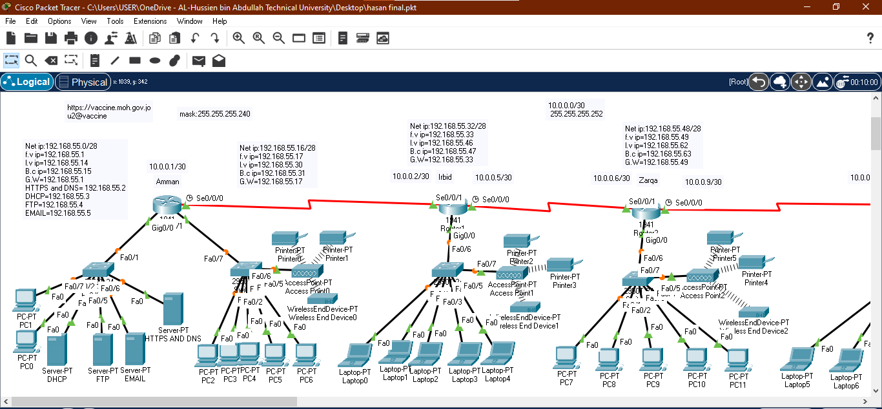

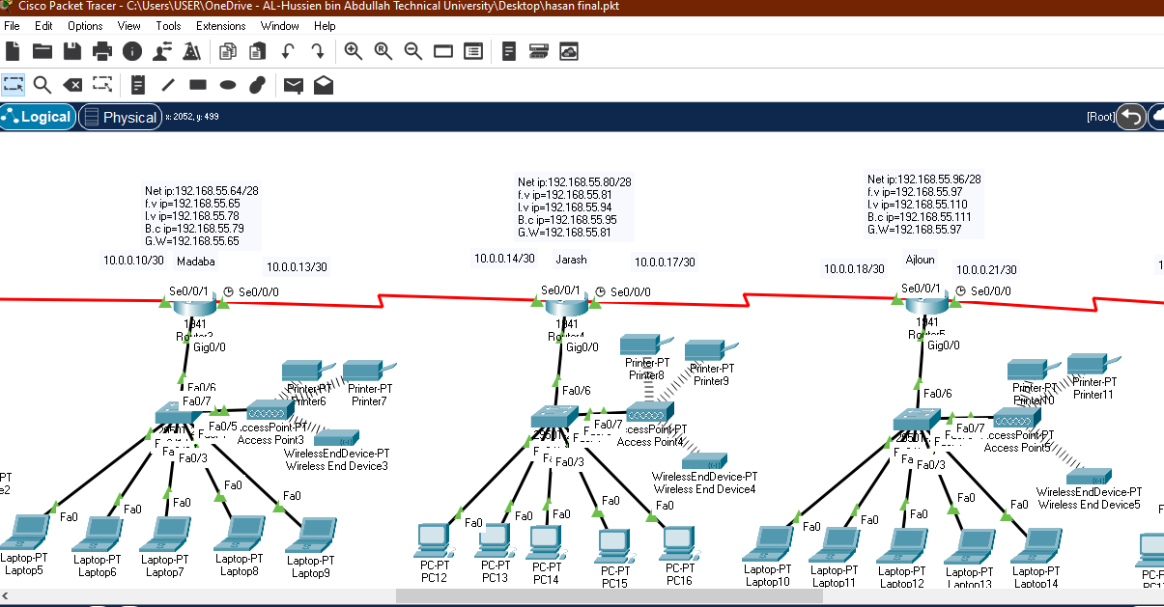

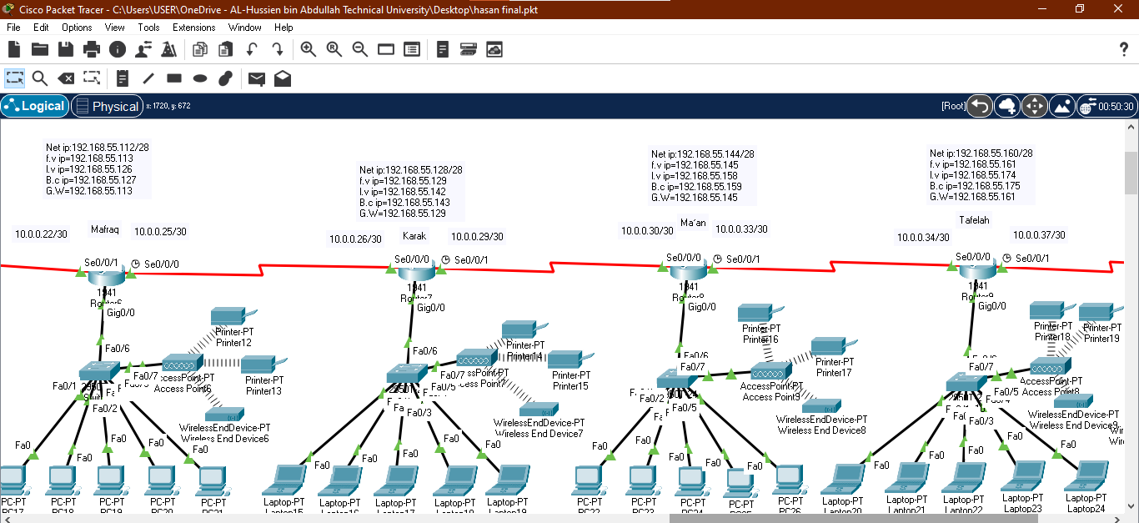

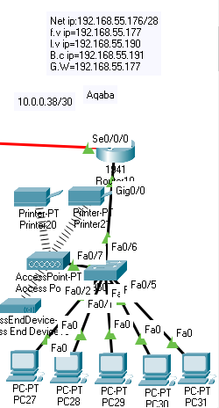

c)

i)

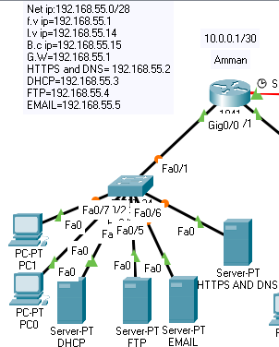

ii and iii )

1. DHCP: 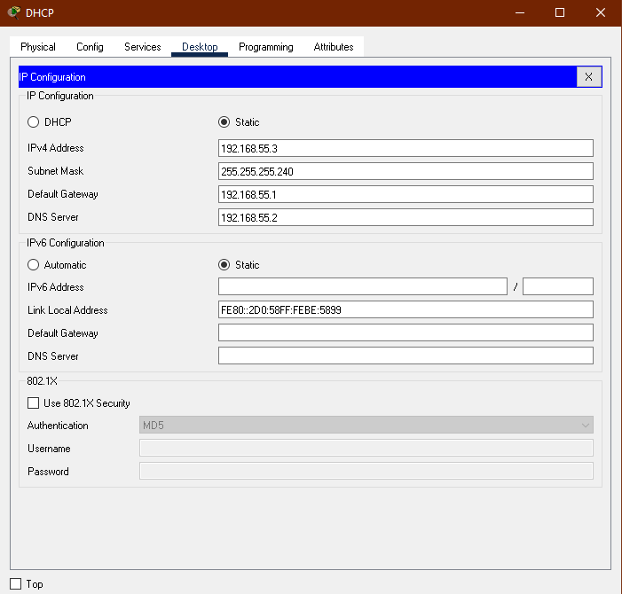

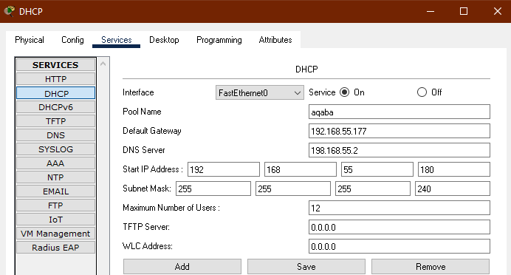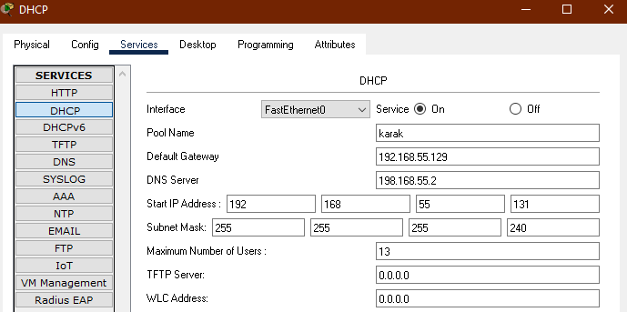

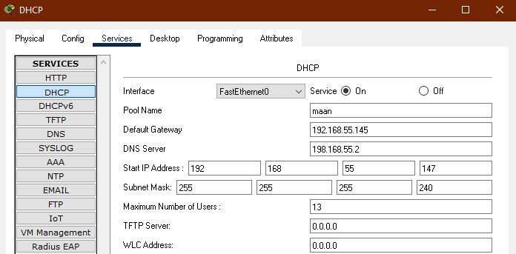

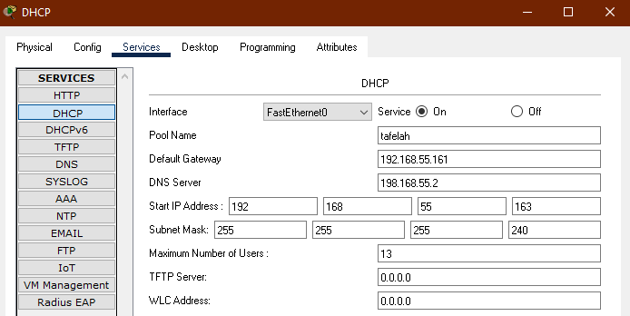

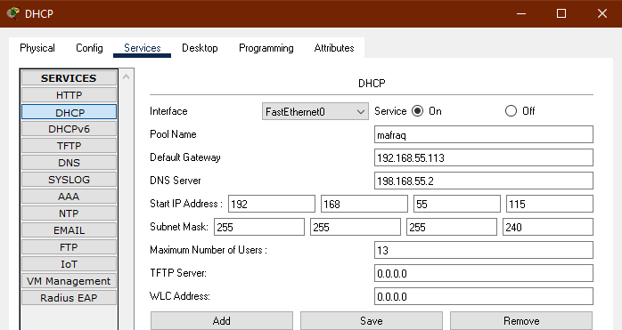

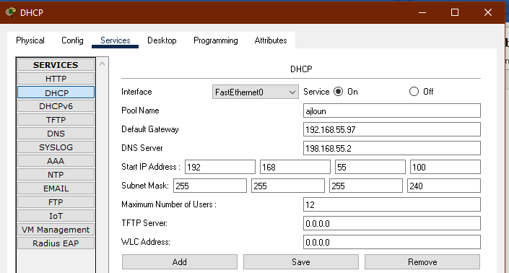

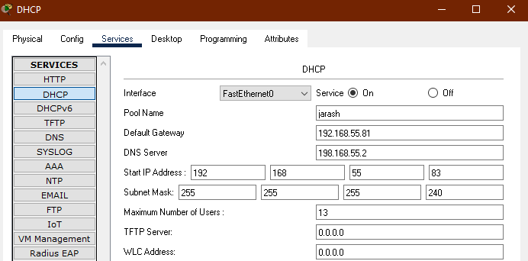

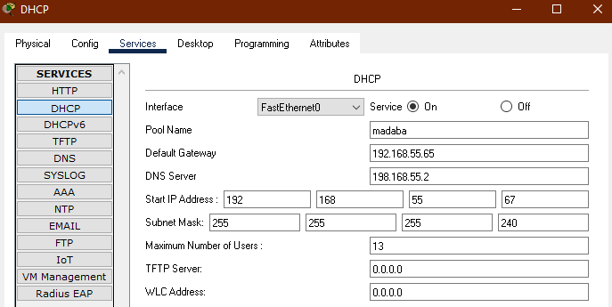

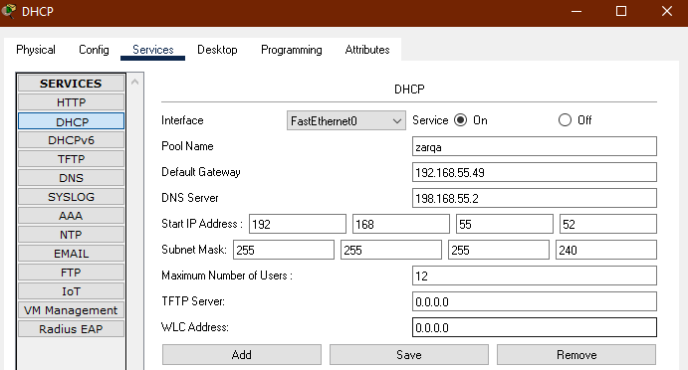

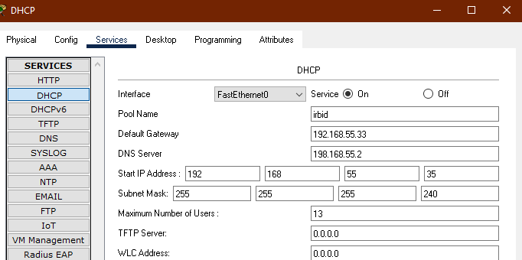

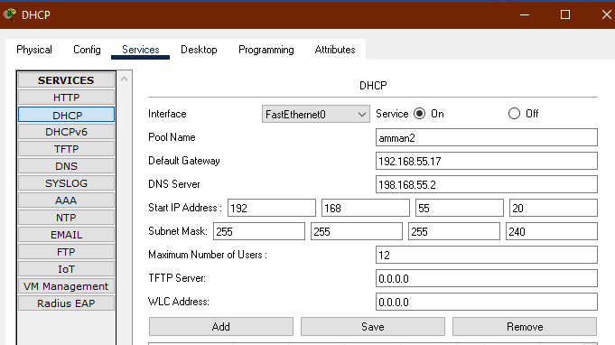

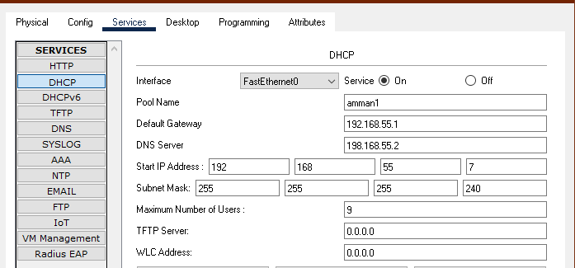

2)FTP:

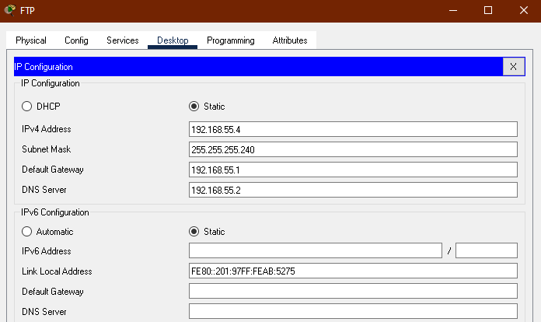

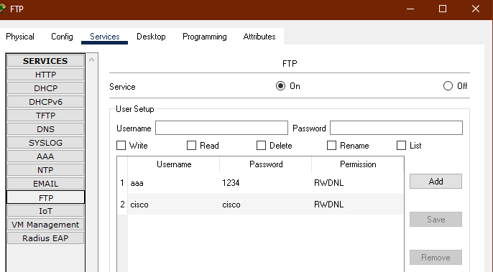

3)EMAIL:

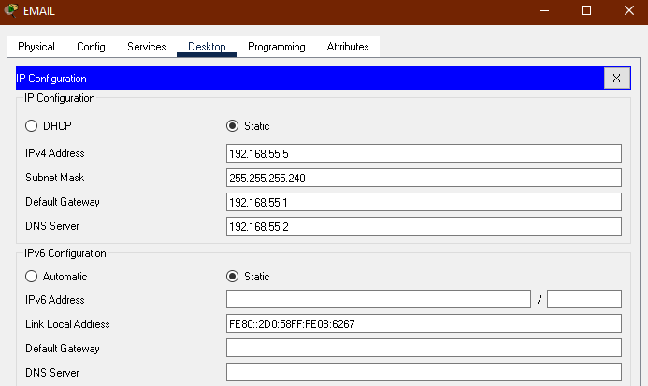

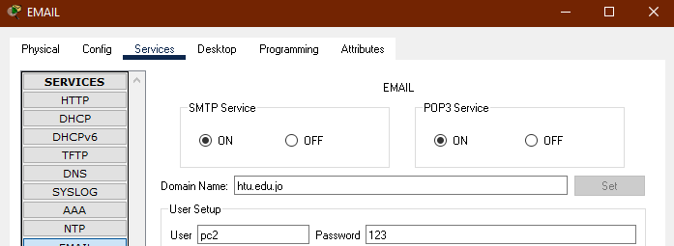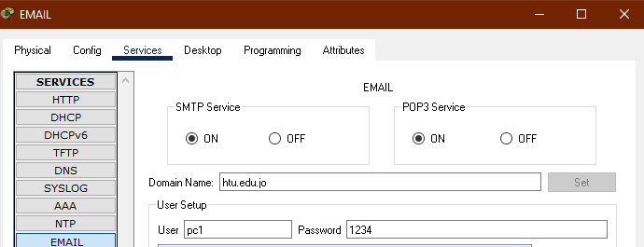

4)HTTPS:

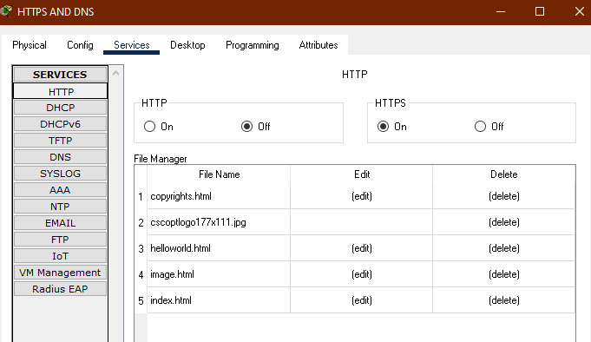

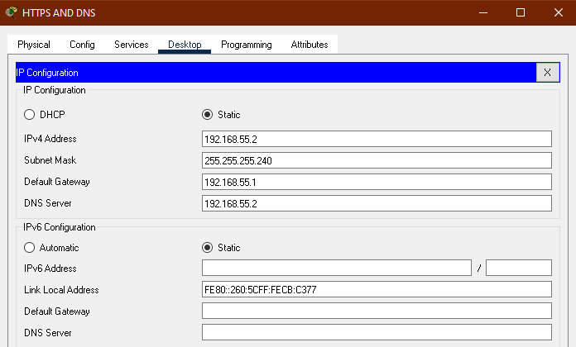

5)DNS:

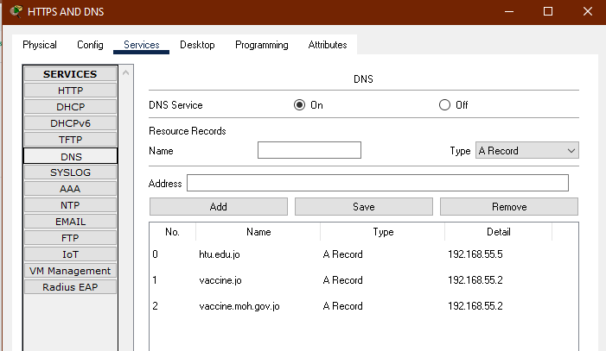

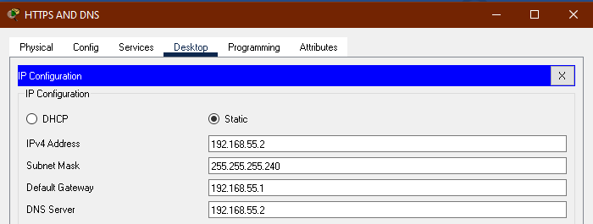

Network Servers: -

DNS: It is used to translate fully qualified domain names such as www.abc.com to its own IP address.

DHCP: It is used to distribute IP addresses to clients on the network so that you do not need to go around each client and configure the IP address manually.

HTTP: It is used to access websites that the device wants.

FTP: To copy or move the file from one computer to another computer or to multiple computers

Email: To send and receive messages between devices.

Network Devices: -

Routers: It helps send packets to their destinations by plotting a path across a sea of ​​interconnected network devices using different network topologies.

Switches: It is used to connect a computer, laptop and router.

Access Points: the access point can technically include a wired or wireless connection, the access point operates at the second OSI layer, the data link layer, and can act either as a bridge that connects a standard wired network to wireless devices or as a router that transmits data from one access point to another.

Printers: It is used to print orders that come from a computer and laptop.

|  |  |  |  |
| --- | --- | --- | --- |
| What to be tested | There is a connection between the devices | View the file in the device | Send an email from one device to another device |
| Tools or commands used for testing | Ping 192.168.55.7 | ftp 192.168.55.4  Username:aaa  Password:1234  ftp>dir |  |
| Expected results | Reply from 192.168.55.7 | Show all files on the device |  |

4) a maintenance schedule:

|  |  |  |
| --- | --- | --- |
| DHCP server | Always check when starting the DHCP Server service. Check if any devices on the network have static IP addresses that are not excluded from the DHCP range. | It usually needs maintenance when the IP address is not properly distributed between network devices.  And when there is no problem, it is maintained every week to ensure its effectiveness. |
| DNS server | To verify that the server is running well, test using the nslookup and check if the DNS server can be accessed from client computers. | It needs maintenance when the connection between the devices and the server is broken. And it is maintained every month in case there is no problem. |
| FTP server | When running the server, make sure that the devices can transfer the files and data they want between each other. | When there is a failure between devices in transferring files and data, then the server needs maintenance to get it back to work. It is maintained every two weeks if there is no problem. |
| Email server | To verify that the server is running well, test using Send a message to a machine. If it works, and the message is connected to a machine, it means that the server is running fine. | When a mail is sent from a device to one of the devices and the mail does not arrive, it is known that there is a problem with the server, so the mail server must be maintained. It is maintained every week to make sure it works well. |
| HTTP server | Usually when the server is running, you must verify that all devices have access to the browser you specified on the server. | When the server is down and the devices cannot access the browser the server wants, an HTTP server must be maintained. It is maintained every two months to ensure its effectiveness. |
| Router | When all the configurations are working on the router, the devices in one router can connect to the devices on the other router, send emails and take the IP Address from the DHCP server. | Always when a problem occurs between one of the routers and does not occur in the other routers, then the router is maintained or removed and another router is assigned with the same specifications. It is usually maintained every six months. |
| Devise | Always make sure that all devices are connected to each other and that they can send mail to all devices and can access the browser. | When a problem in one of the devices, it is usually serviced or the device is replaced with another device. It is usually maintained every year. |

Part 2.2: -

1)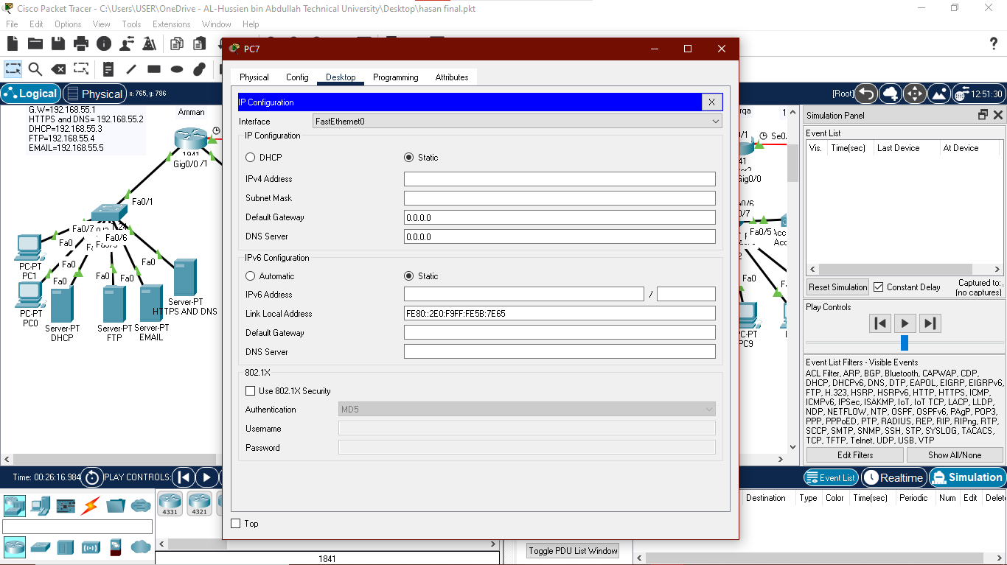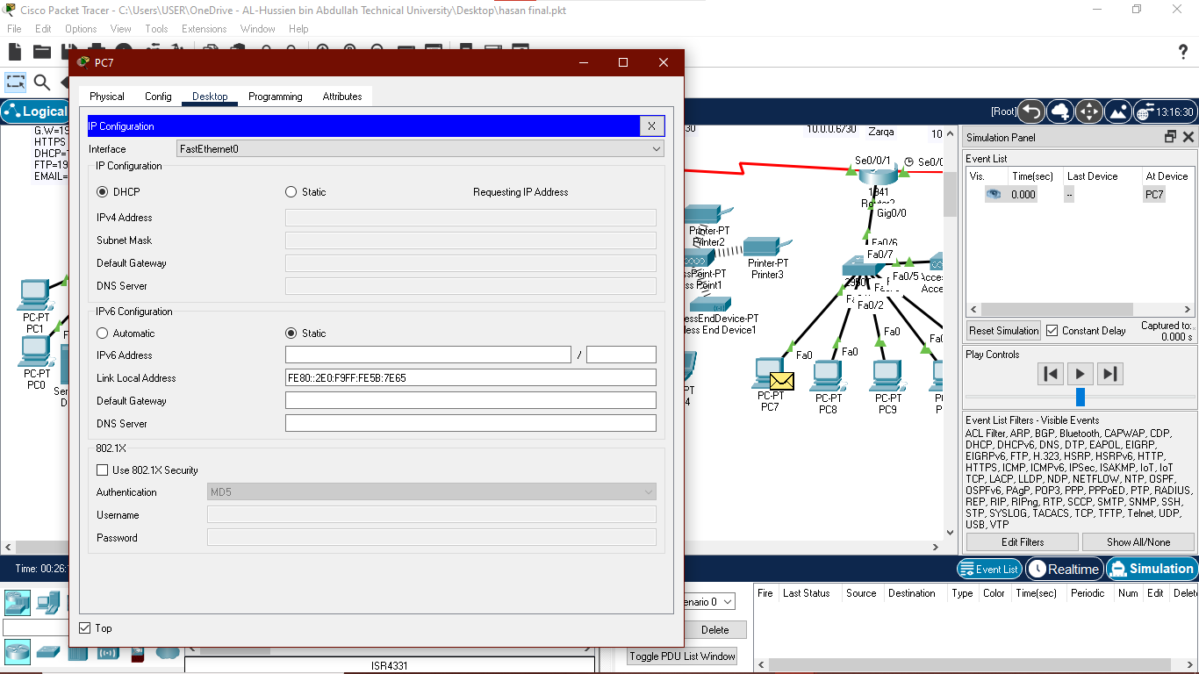

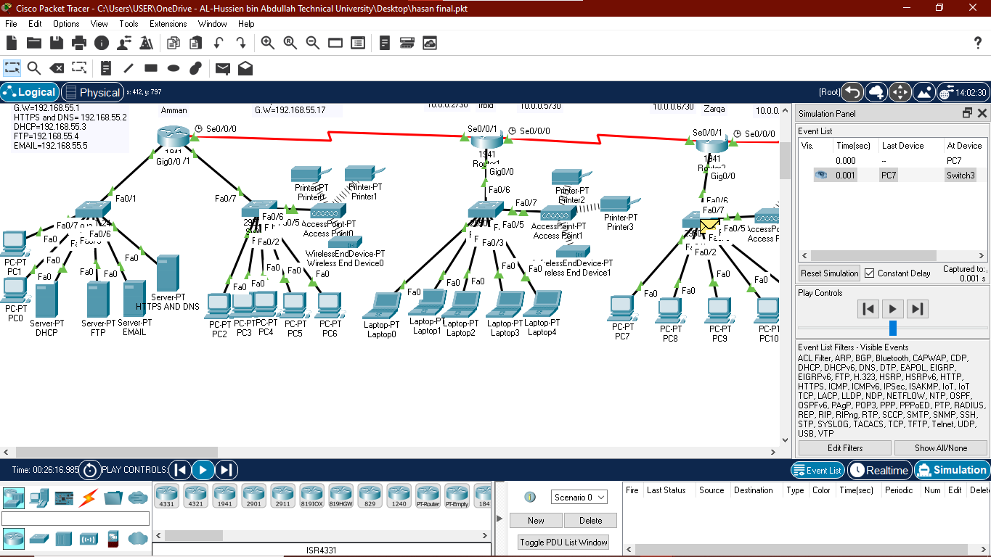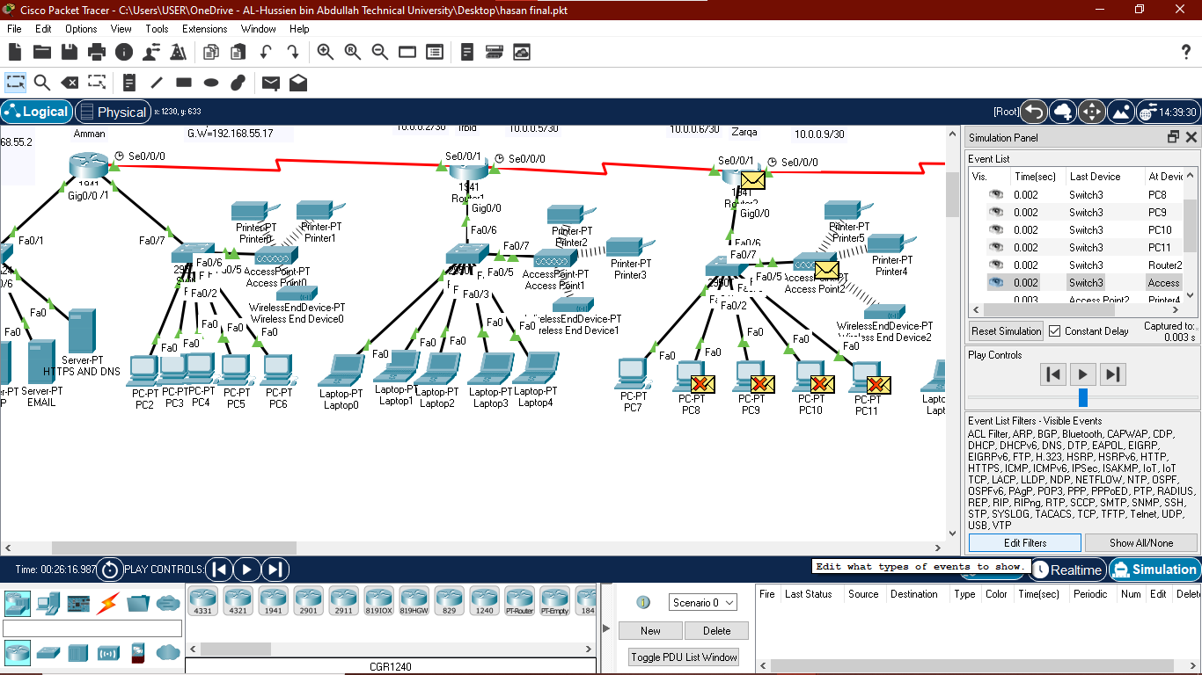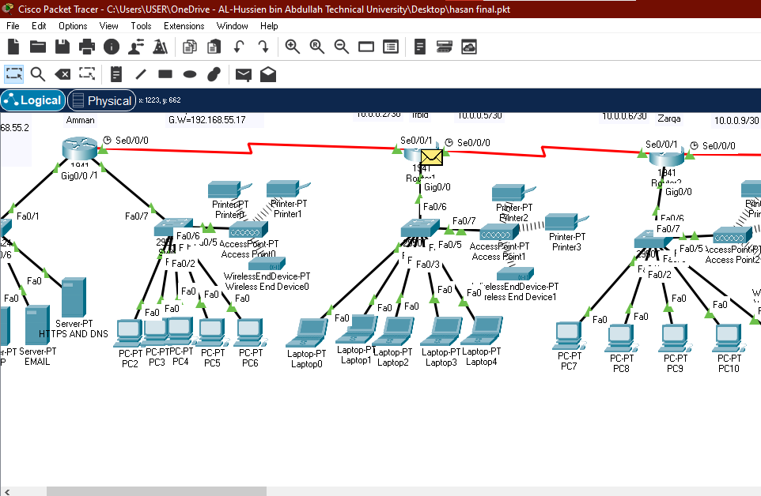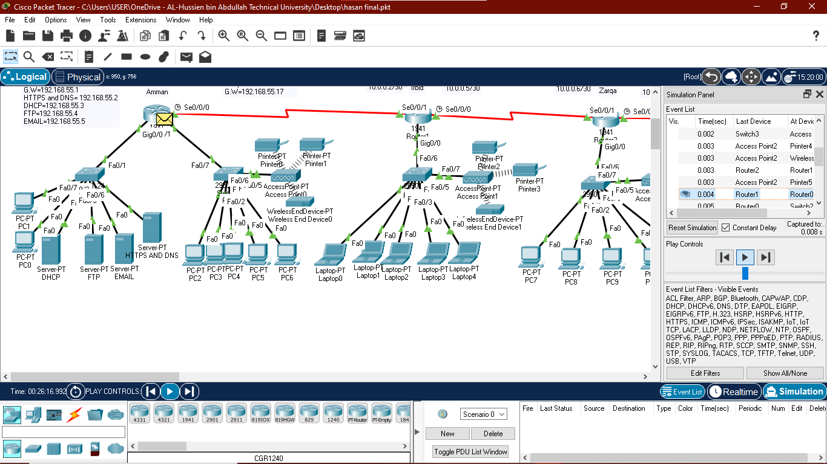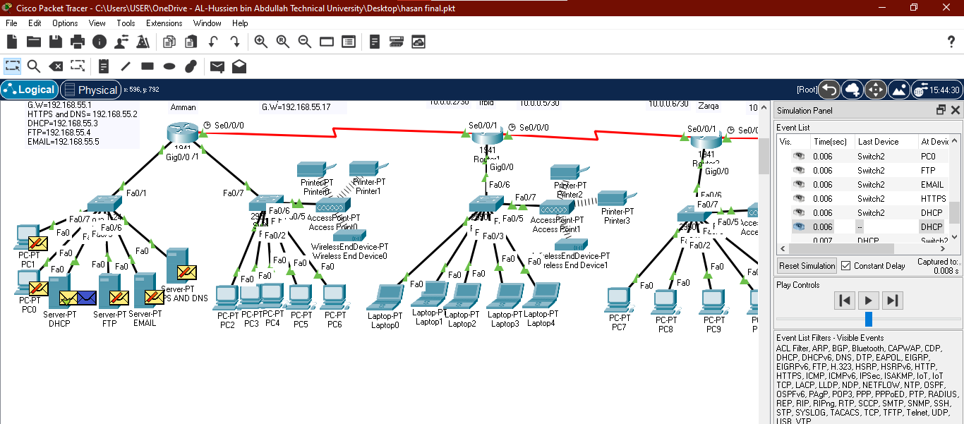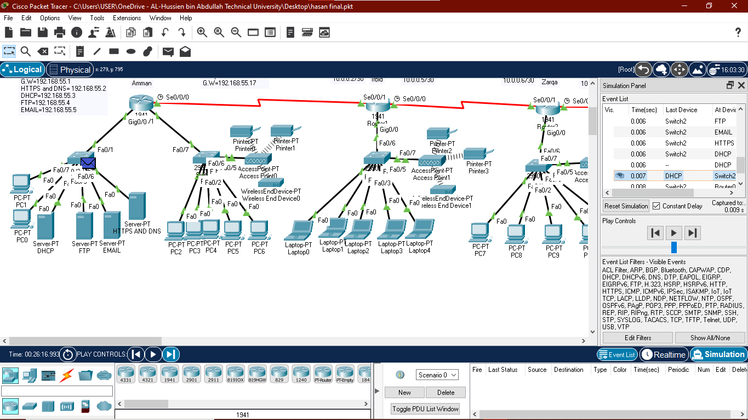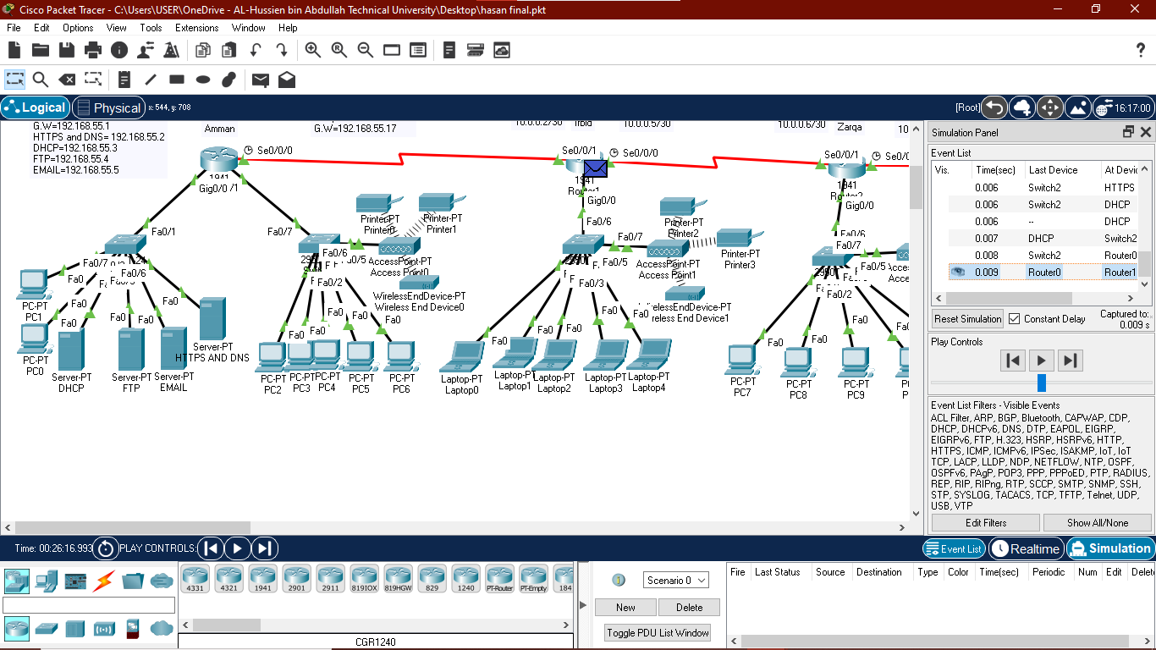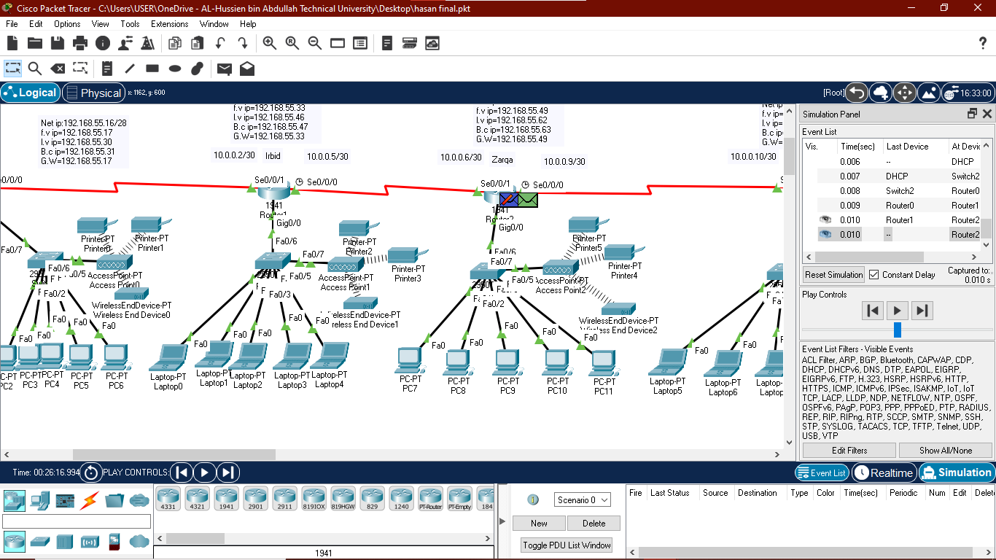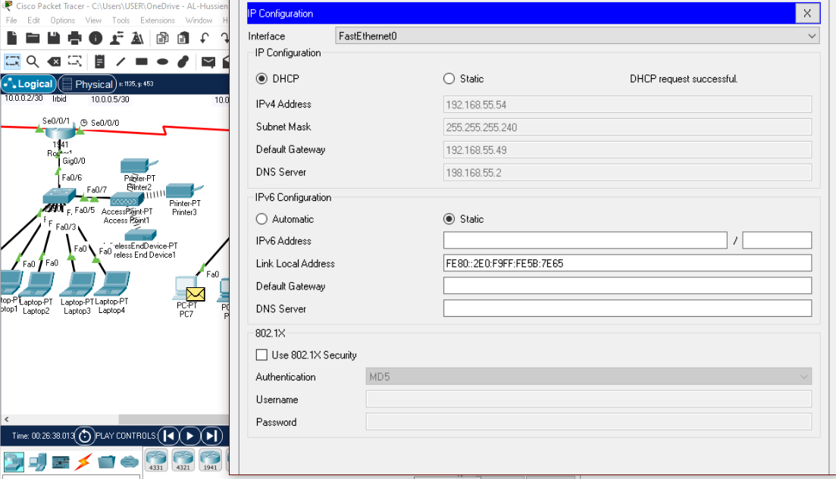

2)

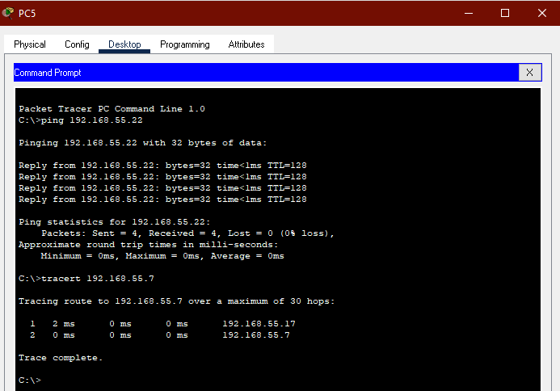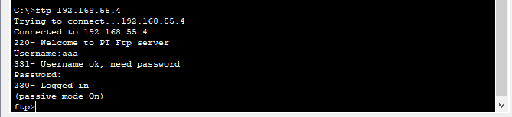

3)

a) Make sure that the devices get an IP address from DHCP. that will take every device in the network on its own IP address.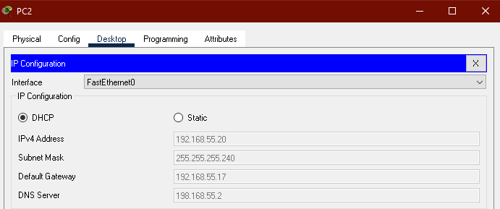

b) Ensure that there is communication between the devices via e-mail and that receiving and sending messages occurs. The device will receive a message from the sending device

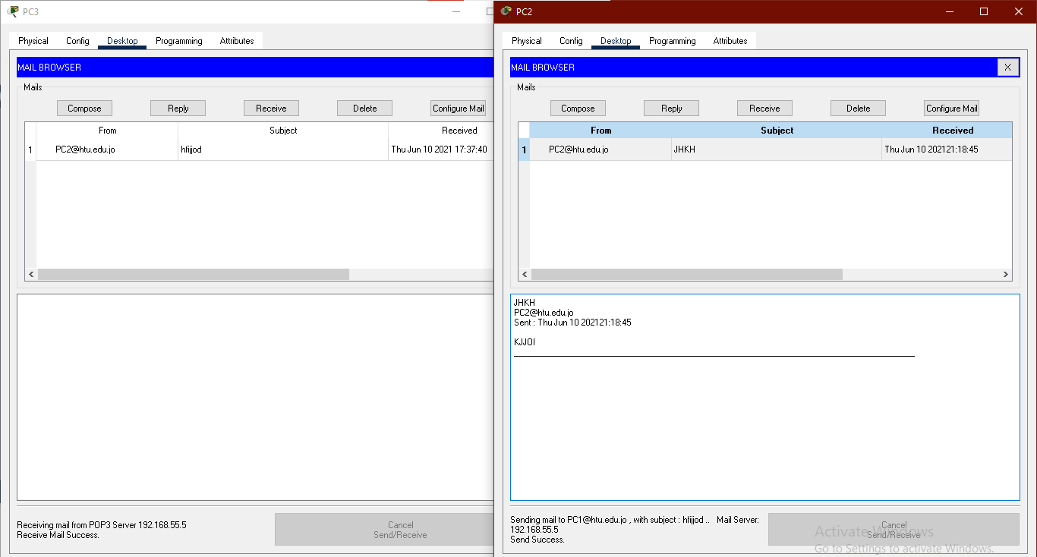

4)

When I add a new device to my network, I must make sure that it will get a new IP address and be able to connect to other devices connected to the network by transferring files, sending and receiving emails, accessing the browser, adding this device to the server for security and knowing that it A new device has been added to the network.

5) 6 REASONS WHY YOU SHOULD ALWAYS UPGRADE: -

1. Cyber Crime Is on the Rise: Unfortunately, there are many talented programmers out there like hackers who know common mistakes programmers make.

So software companies then release a new version of their software to address these security issues.

2. Personal Data Is at Risk: Hackers can obtain personal or important corporate or government information and hold people hostage because of it. Every time a major virus is released, software developers scramble to fix this problem. Staying ahead of each release will keep you at the front of the pack, safe and secure.

3. You Might Not Be Updating Automatically: It is a very serious problem because criminals can access your device and roam all over the network without anyone noticing. Always make sure you have the latest software. The easiest way to get into a hacker is through an old bug in your program.

4. Malware Passes Like the Flu: Upgrading the software can help you avoid this problem. Some antivirus programs will send you to live alerts when they suspect problems. Software synchronization with your email server can mean that you can automatically check all your work email for problems.

5. New Features: Security is a major reason to upgrade software as there are some great benefits of software updates. You will often notice improved functionality and greater ease of use.

6. Support Might End: Leaving programs from development may lead to errors in the programs and also the presence of malfunctions in some of them, which affects the security of the programs and the loss of your data.

